CONDOR
Autonomous Gliding Munition
Hybrid rocket propulsion. Deployable wings. Three-phase autonomous guidance. 50+ km standoff.
Caelus Industries | caelusindustries.com | info@caelusindustries.com
50+ km  Standoff range | <3 m  CEP terminal guidance | Mach 0.9–1.1  Boost velocity | L/D 8–12  Glide ratio | 0  Platform-specific launchers required
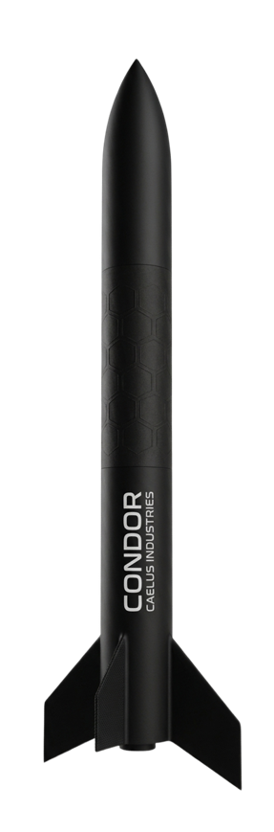
Precision standoff effects at 50-plus km range. Multi-platform. Payload-agnostic. Ecosystem-native.
CONDOR is an autonomous gliding munition combining a throttleable hybrid rocket motor with spring-deployed planar wings to achieve 50-plus km range from multi-platform launch. A three-phase guidance architecture covering INS bootstrap, GPS-aided mid-course and EO/IR terminal homing enables accurate engagement of payload-defined target classes with minimal operator input post-launch. CONDOR integrates natively with Mukagen, the BANE vision ecosystem and the Argus GCS.

COMMERCIAL IN CONFIDENCE | For authorised recipients only | 2026

1. The CONDOR System

CONDOR is composed of three tightly coupled elements: a hybrid propulsion system delivering a tunable boost-sustainer profile, a spring-deployed planar wing airframe enabling efficient unpowered glide, and a three-phase autonomous guidance suite. All three work together to deliver standoff precision effects from a range of launch platforms without platform-specific launcher hardware.
Every element is designed to work together, and each can be independently characterised. Customers can integrate CONDOR into their existing platform and C2 ecosystem and expand usage as their operational envelope matures.
PROPULSION  Throttleable hybrid rocket motor. Boost and sustainer phases. H₂O₂/HTPB primary propellant. N₂O/paraffin secondary. Tunable impulse profile per platform. | AIRFRAME  Al 7075-T6 body. CFRP planar swing wings. Spring-deployed in under 0.5 s. Cruciform NACA 0008 control fins. Payload-agnostic bay. | GUIDANCE  INS bootstrap from platform state vector. GPS mid-course to 3–5 m CEP. LWIR IIR seeker terminal homing. Proportional navigation law.

2. Form Factor and Structures

2.1 Airframe Dimensions
The CONDOR airframe is sized for compatibility with standard aircraft stores and UAV hardpoints. Wing deployment occurs within 0.5 s of ejection and is spring-actuated with no electrical dependency.

Specification | Value | Specification | Value
Length | 1.52 m (5 ft) | Diameter | 152 mm (6 in), fineness ratio 10:1
All-up weight | 25–35 kg propellant-loaded | Wing span (deployed) | 700 mm
Wing configuration | Planar swing-wing, spring-deployed | Wing stow envelope | Stowed within 152 mm body diameter
Tail configuration | Cruciform control fins, NACA 0008 | Fin actuation | Brushless servo-actuated
Wing deployment time | Below 0.5 s | Wing material | CFRP graphite-epoxy prepreg

2.2 Materials
Materials
Body | Aluminium 7075-T6 primary construction with CFRP upgrade path available
Wings | CFRP graphite-epoxy prepreg for low mass and high stiffness
Motor case | 4340 steel or filament-wound CFRP with ablative phenolic liner
Wing airfoil | NACA 64-108 laminar flow profile, proven on SDB DiamondBack

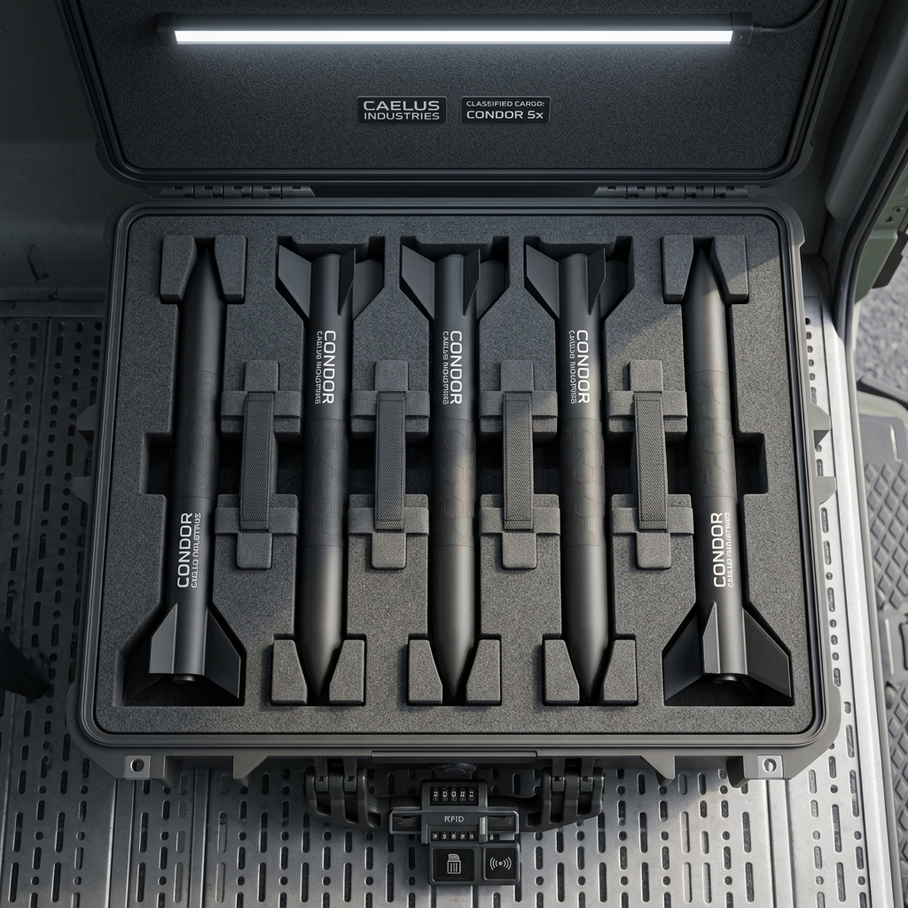 | 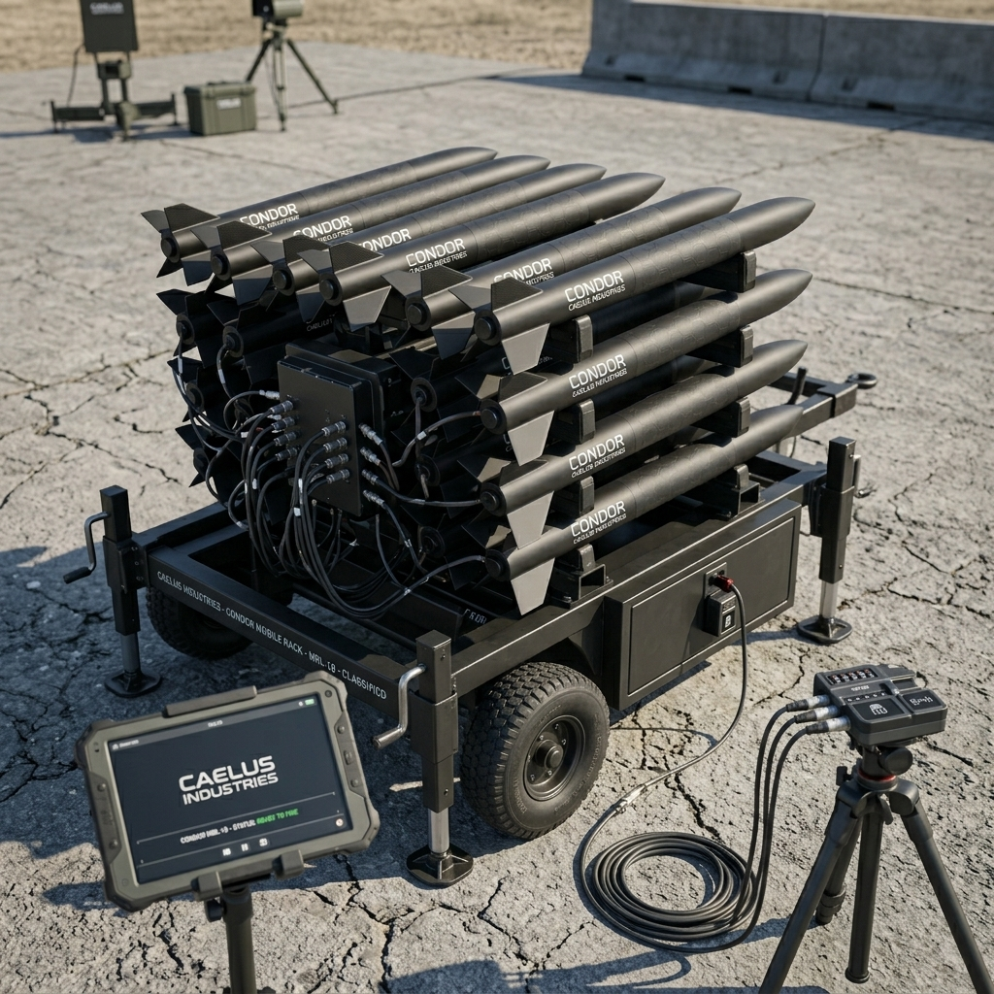
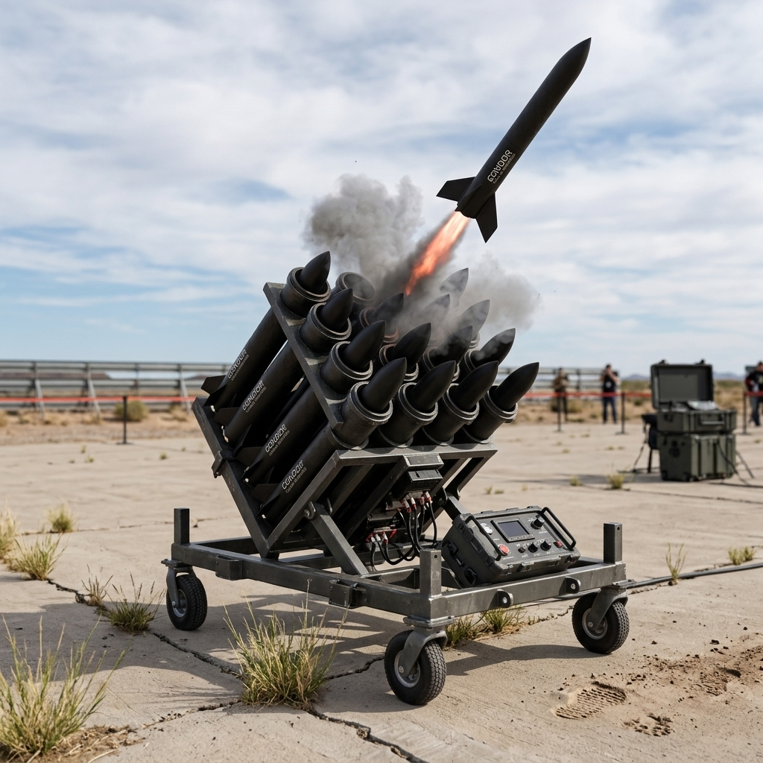
CONDOR carry case (5x) | mobile rack launcher | live ground launch | Caelus Industries

3. Propulsion

3.1 Hybrid Rocket Motor
CONDOR uses a single throttleable hybrid rocket motor delivering boost and sustainer phases from one propulsion unit. The throttleable profile is tunable per launch platform and altitude — a configuration not fielded in this weight class among current standoff glide munitions.

Specification | Value | Specification | Value
Motor type | Single throttleable hybrid rocket motor | Total impulse | 13,000–30,000 N·s
Total propellant mass | 7–11 kg | Boost thrust | 1,200–1,500 N for 8–12 s
Boost terminal velocity | Mach 0.9–1.1 | Boost terminal altitude | 5–8 km
Sustainer thrust | 60–100 N for 60–120 s | Sustainer cruise speed | Mach 0.5–0.7
Glide phase | Unpowered, L/D 8–12 | Glide distance | 30–55 km
Primary propellant | 90% HTP oxidiser / HTPB fuel | Primary Isp | 220–240 s sea-level
Secondary propellant | N₂O oxidiser / reinforced paraffin wax | Secondary Isp | 190–210 s, self-pressurising, higher TRL

3.2 Flight Phases
Flight Phases
Boost | Motor ignites on ejection. 1,200–1,500 N thrust for 8–12 s. Accelerates to Mach 0.9–1.1 and climbs to 5–8 km altitude. Wings deploy within 0.5 s of ejection.
Sustainer | 60–100 N throttled thrust for 60–120 s. Maintains cruise altitude at Mach 0.5–0.7. GPS mid-course guidance active. Datalink telemetry and command link live.
Glide | Unpowered descent. L/D 8–12 glide ratio. Covers 30–55 km. EO/IR seeker slews to target. Terminal homing begins at operator-configured lock-in altitude.
Terminal | Proportional navigation law drives control fins. Autonomous dive at configured angle (30–90 deg). Operator override available until lock-in altitude. CEP below 3 m.

4. Aerodynamics

Specification | Value | Specification | Value
Wing airfoil | NACA 64-108 laminar flow | Glide ratio (L/D) | 8–12 subsonic cruise
Operating speed range | Mach 0.5–1.1 | Operating altitude | 100 m to 8,000 m
Stability | Cruciform tail fins for pitch/yaw/roll | Control authority | Brushless servo fins at all operating speeds

5. Guidance and Navigation

5.1 Three-Phase Guidance Architecture
CONDOR uses a three-phase guidance architecture designed to deliver CEP below 3 m against EO/IR-detectable targets while degrading gracefully under GPS denial and seeker obscuration.

Phase | Sensor / Method | Description
Phase 1 – Ejection | INS bootstrap | Wings deploy within 0.5 s. INS initialises from launch platform state vector. INS alone maintains heading and attitude reference until GPS lock.
Phase 2 – Mid-course | M-Code GPS + tactical MEMS IMU | Tightly coupled GPS/IMU navigation. M-Code for anti-jam. CEP 3–5 m with GPS aiding active. Fallback to INS dead reckoning to last-known coordinates on GPS denial.
Phase 3 – Terminal | Uncooled LWIR IIR seeker | 640×512 focal plane array, 3 deg FOV. Proportional navigation law. Operator crosshair override via datalink available until lock-in altitude. CEP below 3 m.

5.2 Degraded Mode Fallbacks
Degraded Mode Fallbacks
GPS denied | INS dead reckoning to last-known coordinates. Accuracy degrades with time from GPS loss.
Seeker degraded | Operator crosshair designation via datalink provides terminal steering reference.
Datalink lost | Autonomous engagement of last confirmed target coordinates. Configurable abort-to-miss option.
Guidance loop rate | Greater than 20 Hz across all phases.

5.3 Performance
Specification | Value | Specification | Value
CEP with GPS aiding | 3–5 m mid-course | CEP terminal EO/IR | Below 3 m
Guidance loop rate | Greater than 20 Hz | Terminal dive angle | 30–90 deg, configured pre-launch via Argus
Lock-in altitude | Operator-configured | Post lock-in | Autonomous engagement, no operator input required

6. Payload Interface

CONDOR accepts any payload within the bay envelope without airframe modification. The electrical and mechanical interface is fixed across all payload types, enabling rapid payload substitution in the field.

Specification | Value | Specification | Value
Bay length | 150–200 mm | Bay diameter | 152 mm maximum
Payload mass budget | 5–8 kg | Electrical bus | 28 V MIL-spec connector
Fuze interface | Arming discrete, MIL-spec | Data interface | RS-422 serial
Airframe modification required | None | Payload change time | Field-swappable without tooling

7. Launch Platform Compatibility

CONDOR requires no platform-specific launcher hardware. The passive eject interface adapts to fixed-wing pylons, UAV hardpoints, ground vehicle tube launchers and naval rail or VLS canister adapters using a common airframe.

Platform Compatibility
Fixed-wing aircraft | MIL-STD-1760 compatible pylon. Standard aircraft stores interface. No platform-specific launcher required.
UAV / Drone | Ventral bay or hardpoint mount. Compatible with UAV stores interfaces across weight classes.
Ground vehicle | Tube or box launcher with pneumatic ejection. Containerised logistics-friendly format.
Naval surface vessel | Deck-mounted rail or VLS canister adapter. Suitable for surface combatants and patrol vessels.

8. Communications and Datalink

Specification | Value | Specification | Value
Datalink band | S-band or UHF | Datalink range | Greater than 30 km line-of-sight
Video downlink | 2–4 Mbps | Command uplink | 10–50 kbps
Encryption | AES-256 FHSS | Pre-launch cue source | Mukagen, BANE, external radar or EO sensor
Telemetry | Optional downlink for battle damage assessment | Terminal phase | Autonomous; operator override until lock-in altitude

9. Engagement Performance

Specification | Value | Specification | Value
Total range | 50–75 km from ground launch | Range breakdown | Boost + sustainer + glide phases combined
Terminal CEP | Below 3 m in EO/IR terminal phase | Terminal dive angle | 30–90 deg, warhead-dependent default, Argus-configured
Operating altitude | 100 m to 8,000 m | Datalink range | Greater than 30 km line-of-sight
Autonomous terminal engagement | No operator input required post lock-in | Operator override | Available via datalink until configurable lock-in altitude

10. Integration

CONDOR is designed as a first-class member of the Caelus ecosystem. Native integration with Mukagen, BANE and Argus is supported from day one. Standalone operation without any external system is also fully supported.

Ecosystem Integration
Mukagen / BANE | Accepts live target state vector (position, velocity, class) via ZMQ pre-launch or post-launch. Enables direct cueing from autonomous counter-UAS detection pipeline.
Argus GCS | Pre-launch mission planning covering waypoints, dive angle, lock-in altitude and abort behaviour. In-flight operator retarget, monitoring and abort via Argus voice and UI pipeline.
Standalone | Self-acquires target without external cue if Mukagen and BANE are unavailable. Full autonomous engagement capability with onboard sensors alone.
ATAK / C2 | Compatible with standard command and control systems including ATAK and equivalent C2 frameworks.

11. Key Differentiators

CONDOR vs. existing standoff glide munitions

Novel throttleable hybrid propulsion.
Existing standoff glide munitions such as GLSDB and JSOW use solid rocket boosters or turbofan sustainer motors. CONDOR uses a throttleable hybrid rocket motor enabling a tunable boost-sustainer profile across launch platforms and altitudes — a configuration not fielded in this weight class.
Payload-agnostic airframe.
The same airframe accepts any payload within the bay envelope with no modifications required. The fixed electrical and mechanical interface enables field payload substitution in minutes.
True multi-platform compatibility.
The passive drop/eject interface requires no platform-specific launchers across fixed-wing aircraft, UAV hardpoints, ground vehicle tube launchers and naval rail or VLS canister adapters.
Ecosystem-native from day one.
First-class integration with Mukagen, BANE and Argus is built in from the outset. CONDOR can accept a live target state vector from the Mukagen counter-UAS pipeline and receive mission updates from Argus in flight.
Three-phase autonomous guidance with graceful degradation.
Each guidance phase has a defined fallback: GPS denial falls back to INS dead reckoning, seeker degradation falls back to operator crosshair designation, and datalink loss falls back to autonomous engagement of last confirmed coordinates.

12. Get Started

Requirements Review  We review your platform inventory, target environment, payload requirements and regulatory constraints and confirm deployment scope. | Demonstration  Guided walkthrough of the CONDOR guidance and integration architecture. Simulation or ground-test demonstration where feasible. | Pilot Programme  Structured pilot engagement covering integration with your platform and C2 ecosystem. Full performance data delivered on completion.

caelusindustries.com | info@caelusindustries.com
COMMERCIAL IN CONFIDENCE · Caelus Industries · 2026 · Not for external distribution without authorisation

